**Assignment No 2**

**Task No 1: CLO 1**

Automatically search the dollar rate from google.com as we have searched during class using selenium and then store this rate to a variable temp, then check if the rate is less than 260 then echo "congratulations" and if the rate is > than 260 then echo "Oh No" else echo "No change in the rate".

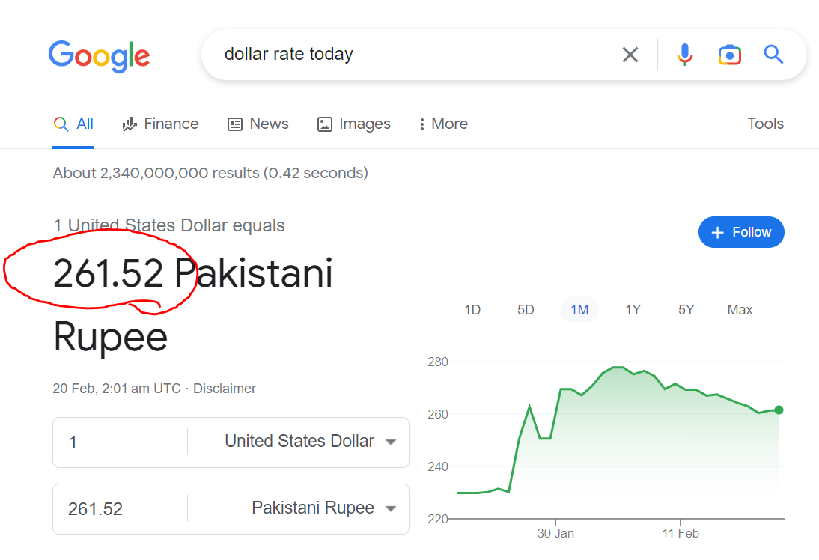

**Task No 2: CLO 1**

Search Online Calculator and give two values and then test 4 cases.

1. 5+10 = 15
2. 10-5 = 5
3. 10*5 = 50
4. 10/5 = 2

Automatically test above 4 cases if answers are equal then test case pass otherwise fail

